Task 4:
Configuring GitHub with Jenkins

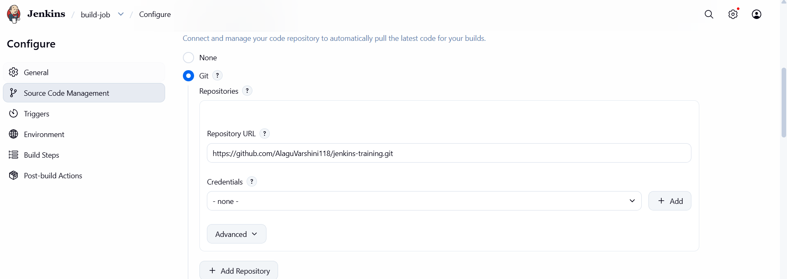
Configuring Jenkins withGitHub

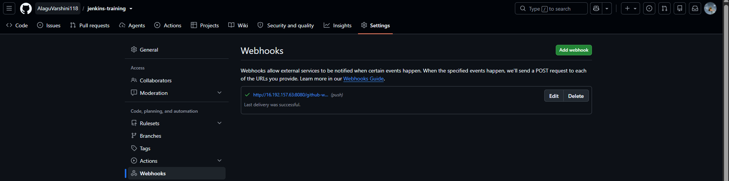
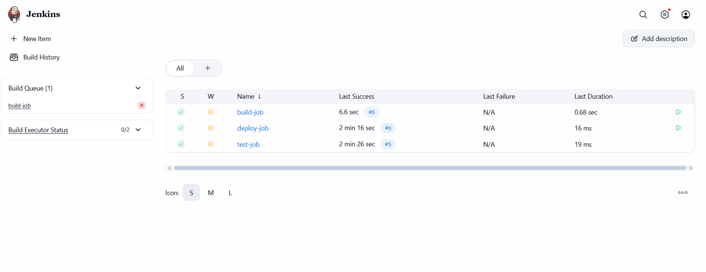
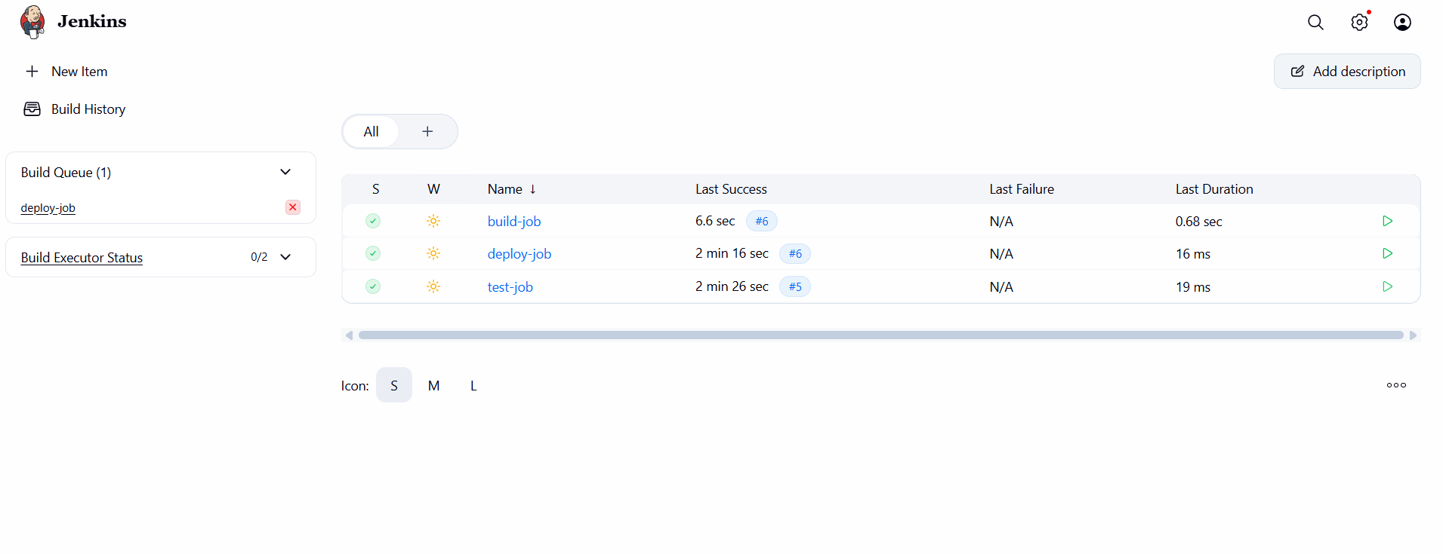
Sample.html is being triggered

